
ACADEMIC YEAR 2nd TERM ENGLISH PRACTICE EXAM for 12-A

Full Name: Class – Number:

READING (30 PTS)

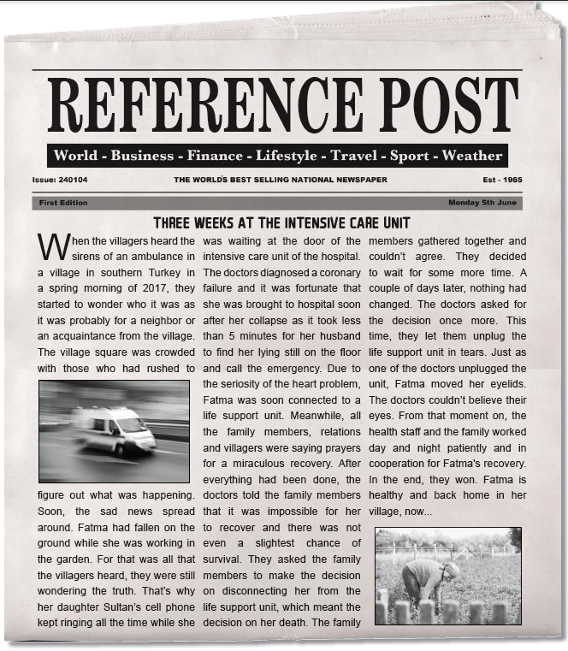
- Read the text and give full-answers to the questions (4x3=12)
1. Why were the villagers worried? __________________________________________________________
2. What did Fatma suffer from? _ ___________________________________________________________
3. Why was Fatma connected to the life support unit? ___________________________________________
4. How did the doctors feel when Fatma moved her eyelids? _ ____________________________________
- Below is a jumbled list of the events in the news story. Put them into the correct order.(8x1=8)
___ Fatma moved her eyelids.
___A doctor unplugged the device.
___The family let the doctors disconnect Fatma from the life support unit.
___Fatma fell on the ground.
___People gathered together in the village square.
___Her husband found her lying still and called the emergency.
___The ambulance arrived.
___Fatma recovered miraculously.
C) Write Turkish meanings of the words.(10x1=10p)

rush: miraculous: connect:
recover: unplug: patiently:
villager: neighbor: decision:
life support unit:

WRITING (20 PTS)

Make a summary of the Reading text from the previous page.Use paraphrasing.

LISTENING (25 PTS)
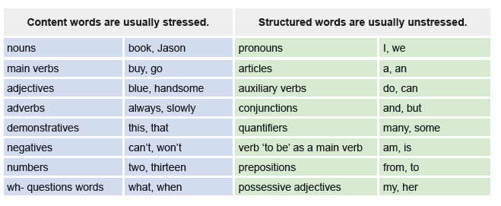

Look at the table on the left page , listen and find the stressed words.
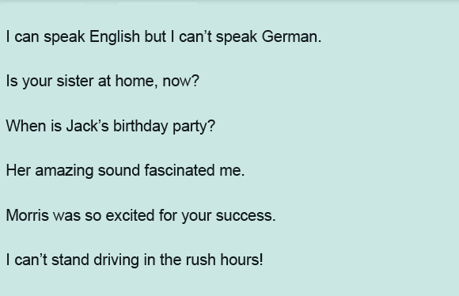

SPEAKING (25 pts)
Topic:

Content | 0 | 1 | 2 | 3 | 4 | 5
Pronunciation | 0 | 1 | 2 | 3 | 4 | 5
Fluency | 0 | 1 | 2 | 3 | 4 | 5
Accuracy | 0 | 1 | 2 | 3 | 4 | 5
Vocabulary | 0 | 1 | 2 | 3 | 4 | 5

GOOD LUCK

