Ad-Soyad : Alınan Puan:
Numara : Alınan Not :
EĞİTİM-ÖĞRETİM YILI ………………….. ANADOLU LİSESİ
2. DÖNEM 10 TMA SINIFI GEOMETRİ DERSİ TELAFİ YAZILI SORULARI

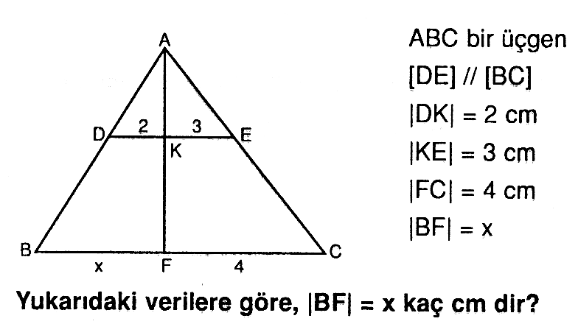
------------------------------------------------------------------------------------------------------------------------------------------------------

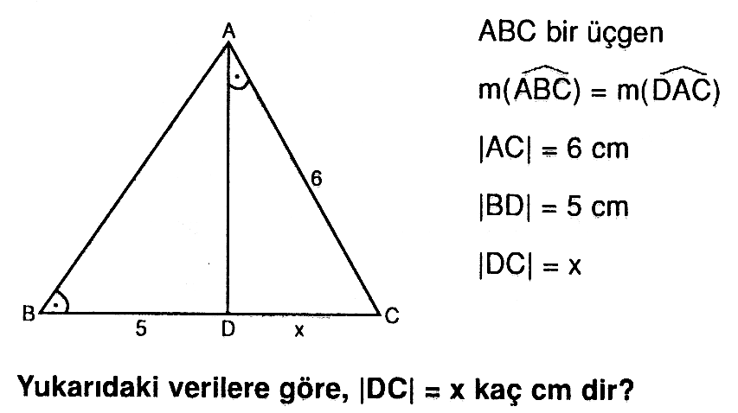
www.sorubak.com
------------------------------------------------------------------------------------------------------------------------------------------------------

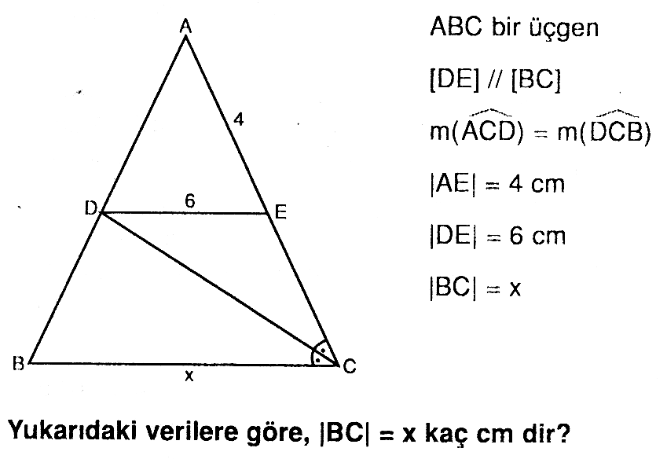
------------------------------------------------------------------------------------------------------------------------------------------------------

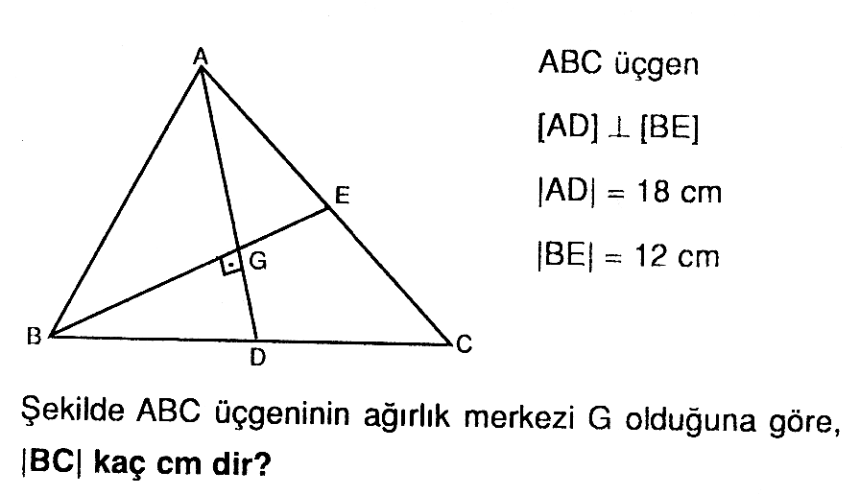
------------------------------------------------------------------------------------------------------------------------------------------------------

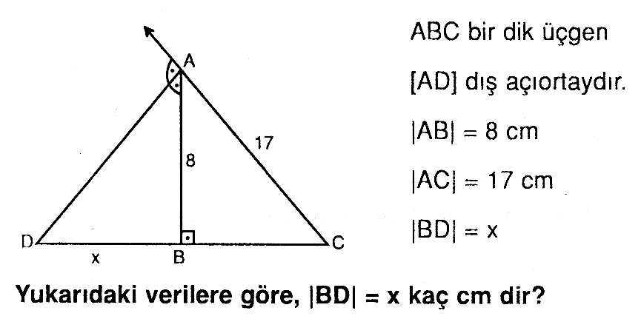

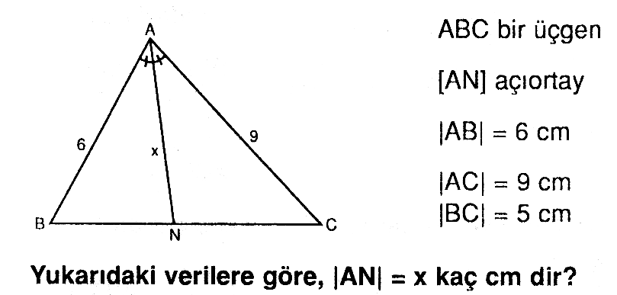

-------------------------------------------------------------------------------------------------------------------------------------------------------

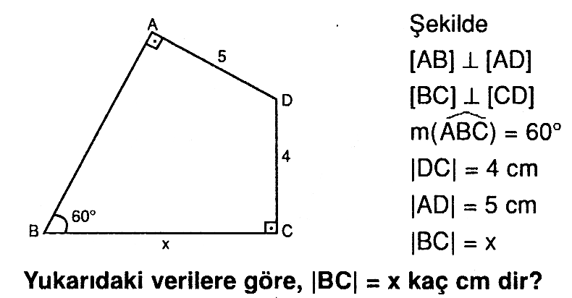

-------------------------------------------------------------------------------------------------------------------------------------------------------

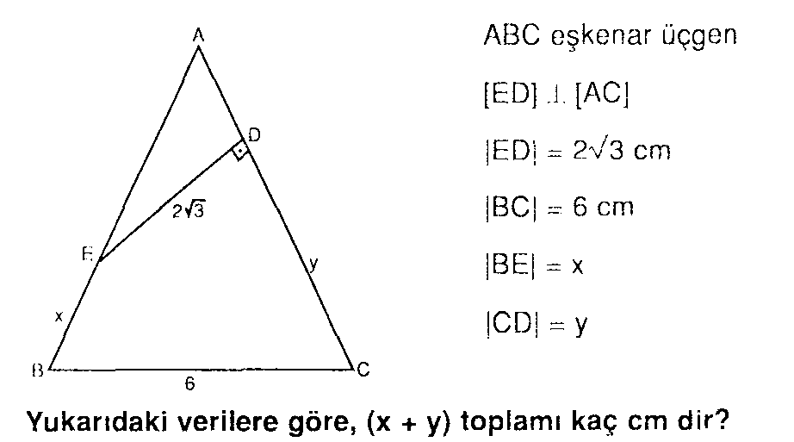

-------------------------------------------------------------------------------------------------------------------------------------------------------

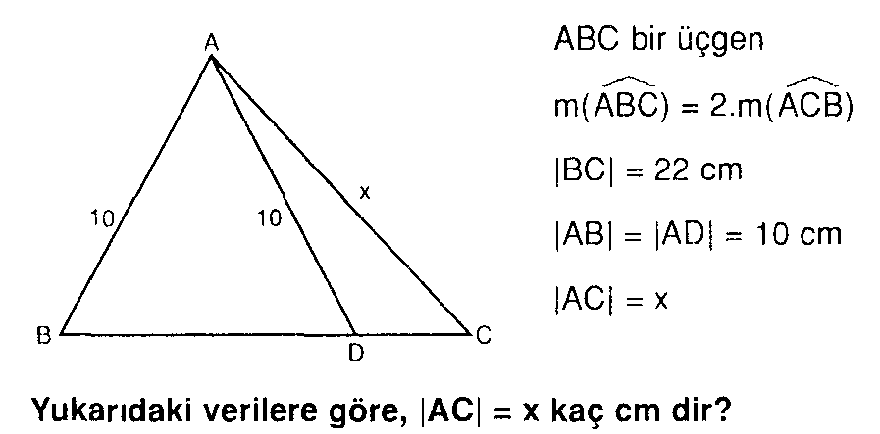
www.sorubak.com

-------------------------------------------------------------------------------------------------------------------------------------------------------

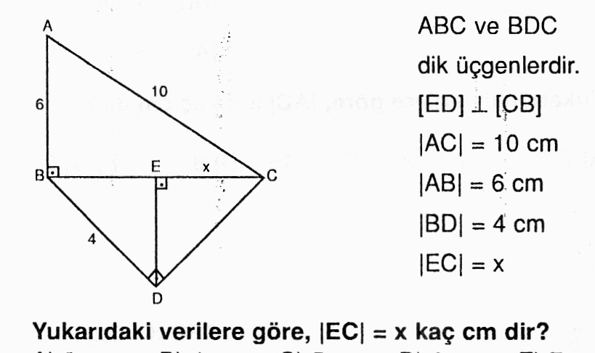
------------------------------------------------------------------------------------------------------------------------------------------------
Her sorunun doğru cevabı 10 puandır. Başarılar Dilerim

