Soru 1  Soruda verilen altı çizili cümleye anlamca en yakın seçeneği bulunuz.  Tom : Hello Mark! What's up?  Mark : Nothing much.  A) Where are you?  B) What is the weather like?  C) What do you do?  D) Where do you live?  E) How is it going?  Soru 2  Soruyu parçaya göre cevaplayınız.  Hi! I am Karen and I am from Cambridge. It is in the UK. My dad is from Greece and my mom is Spanish, so we can speak three languages at home.I am fourteen and I have got two brothers. Jack is sixteen and Tom is thirteen. At home, we spend time playing computer games and doing our homework. My dad is a Maths teacher. He helps us when we don't understand at school.  What nationality is Karen's father?  A) Welsh  B) Irish  C) Spanish  D) British  E) Greek  Soru 3  Anna works at a café. She serves food and drink to people. She is a ...... .  A) student  B) chemist  C) waitress  D) teacher  E) journalist  Soru 4  Jenny : Hello! My name is Jenny. What is your name?  Thomas : Hi! I’m Thomas. ......  Jenny : Me, too.  A) How are you?  B) Nice to meet you!  C) See you later.  D) How old are you?  E) What is your address?  Soru 5  Diyaloğu tamamlayan en uygun ifadeyi bulunuz.  Jasmine: Do you go to the gym everyday?  Karen : No,I don't.  Jasmine : ...... ?  Karen : Twice a week.  A) What time do you get up  B) What do you do everyday  C) When do you go to the gym  D) How often do you go to the gym  E) What time do you go to the gym  Soru 6  Soruyu paragrafa göre cevaplayınız.  I am a big fan of Rihanna. Her full name is Robyn Rihanna Fenty, but her fans know her as Rihanna. She was born on 20th February, 1988. She is tall. She is 173 cm. She is really slim and fit. Her natural hair color is dark brown, but she dyes it very different colors.  Which question does not have the answer in the text?  A) Where is she from?  B) What is her full name?  C) How tall is she?  D) What is her natural hair color?  E) What does she look like?  Soru 7  Choose the correct option.  A: Would you like to live in a big city or a small town?  B: I don‘t like to live in a big city because big cities are crowded and unsafe. Small towns are ...... .  A) peaceful  B) lively  C) old  D) busy  E) noisy  Soru 8  Diyaloğu en uygun şekilde tamamlayan seçeneği bulunuz.  Jack : Hi Mike, we have got a new friend in our school. She is Jane. She is from England.  Mike : Really? That is fine, I want to meet ...... .  A) him  B) his  C) her  D) she  E) he  Soru 9 Aşağıdaki grafiğe göre aileyi tanıtan paragrafı bulunuz.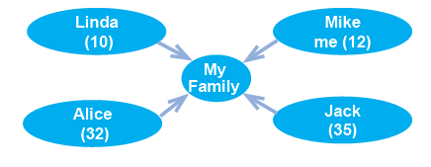A) Hello, I am Mike. I have got a big family. Alice is my sister. She is ten. My dad is Jack. He is thirty five. Linda is my mom. She is thirty two.  B) Hello,my name is Linda. My brother is ten years old. He is Jack. Mike and Alice are my parents. They are thirty five and thirty two.  C) Hi, I am Mike. I have got a small family. Alice is my mom and she is thirty two. Jack is my dad. He is thirty five. I have got a sister. Her name is Linda. She is ten.  D) Hi, I am Jack. I have got a small family. Linda is my mom and Mike is my dad. Alice is my sister. She is twelve.  E) Hello, I am Alice. I have got a small family. Mike and Linda are my parents. They are thirty five and thirty two. Jack is my brother. He is eleven.  Soru 10  Soruyu paragrafa göre cevaplayınız.  I am a big fan of Rihanna. Her full name is Robyn Rihanna Fenty, but her fans know her as Rihanna. She was born on 20th February, 1988. She is of medium height. She is 175 cm tall. She is really slim and fit. Her natural hair color is dark brown, but she dyes it very different colors.  Which one is wrong according to the paragraph?  A) Her natural hair color is dark brown.  B) She is over twenty.  C) She is fat.  D) She dyes her hair.  E) She is fit. | Soru 11  I’m a university student and a part - time waitress at a café. ...... .  A) I work only in the afternoons  B) I’m at the school all day long  C) I spend my whole day in the laboratory  D) I work there as a chemist  E) I teach dancing to my students  Soru 12  Norah: How often do you go to the cinema?  Emma: ......  A) I think they are nonsense.  B) I go on a picnic every weekend.  C) I don’t go to school at weekends.  D) I am going home now.  E) I go there once a week.  Soru 13  Diyaloğu tamamlayan en uygun ifadeyi bulunuz.  Ashton : I want to send a letter to my penfriend in Germany. ...... ?  Betsy : It is opposite the market.  A) Where is the nearest library?  B) How can I go to the bakery?  C) Is there an information office near here?  D) Could you tell me where the post office is?  E) Is there a school near the post office?  Soru 14  Soruda verilen altı çizili cümleye anlamca en yakın seçeneği bulunuz.  Albert: What is your job?  Brian : I am a waiter.  A) What do you do?  B) What do you like?  C) What do you do on Sundays?  D) What's up?  E) What are you doing?  Soru 15  Aşağıdaki cümleler verilen şıklarla tamamlandığında boşta kalan seçeneği bulunuz.  Asia is ...... than Europe.  Elephants are ...... than lions.  Bungee jumping is ...... than chess.  Riding a bicycle is ...... than driving a car.  A) heavier  B) more crowded  C) healthier  D) more exciting  E) happier  Soru 16  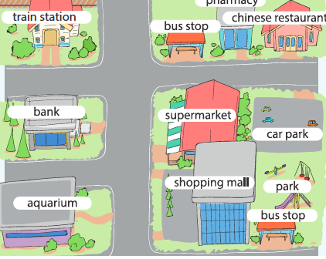  Soruyu haritaya göre cevaplayınız.  The bank is ...... the supermarket.  A) between  B) near  C) next to  D) in  E) opposite  Soru 17  Boşluğa gelebilecek uygun seçeneği işaretleyiniz.  Mum gets angry with Ayşe because her room is always...... .  A) stressed  B) messy  C) busy  D) well-organized  E) tired  Soru 18  Diyaloğu tamamlayan en uygun ifadeyi bulunuz.  Sandy : What do you have in your classroom?  Becky : ...... .  A) Two wardrobes  B) A cooker  C) A computer  D) Three beds  E) A cellar  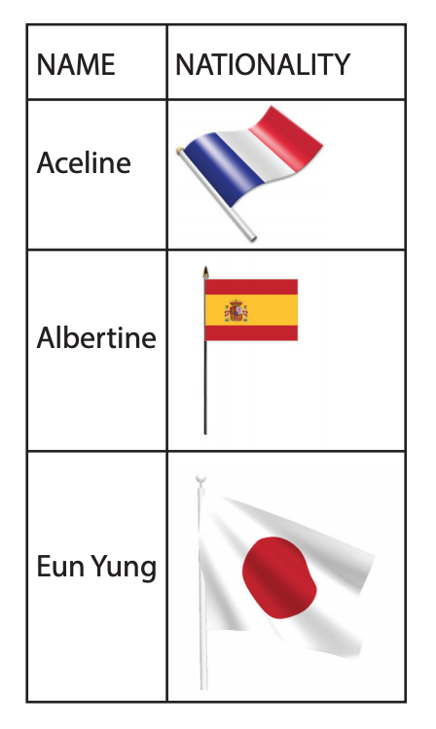  Soru 19  Aceline is from ...... .  A) Spain  B) Germany  C) the USA  D) France  E) Holland  Soru 20  Verilen paragrafı en uygun şekilde tamamlayan seçeneği bulunuz.  Hello, I am Zafer. I am a teacher. I live in Kayseri. This is Cenk. He is my twin. He is a doctor and he lives in Ankara. Although we are twins, ...... . For example, I drink coffee for breakfast but he hates it. He drinks tea. I go to bed early and get up early but he usually goes to bed late and he gets up late.  A) we love our parents  B) we have different life styles  C) we sometimes have breakfast  D) we get on well each other  E) we enjoy similar things
CEVAPLAR: 1-E 2-E 3-C 4-B 5-D 6-A 7-A 8-C 9-C 10-C 11-A 12-E 13-D 14-A 15-E 16-E 17-B 18-C 19-D 20-B

