**2020-2021 ……………….. Anadolu Lisesi 9.Sınıf İngilizce Dersi**

**1.Dönem 1.Ortak Yazılı**

**Name and Surname:**

**Number: Class:**

**A)Put the dialogue into the correct order.(8X3=24)**

**…….Robert:** I’m fine. How about you?

**…….Isaac:** What are you doing?

**…….Isaac:** Hello, Robert. How are you?

**…….Robert:** Thank you for offering. I have another plan.

**……-Robert:** There’s a basketball match between our school team and

our neighbouring school. I’m going to see it.

**…….Robert:** See you. Take good care.

**…..Isaac:** Fine, thank you. Do you have any plans for this evening? If not, you can come round to our home.

**…….-Isaac:** How nice! I hope your team wins. See you. Good bye.

**B) Fill in the blanks with a suitable word from the box. Be careful, there are 2 extra jobs(6X3=18)**

|  |  |  |  |
| --- | --- | --- | --- |
| **restaurant** | **bank** | **theater** | **post office** |
| **aquarium** | **pharmacy** | **supermarket** | **shopping center** |

1. You can send a parcel at a /an ____________________.

2. You can take a loan at a /an ____________________.

3. You can reserve a table at a /an ___________________.

4. You can rehearse a play at a / an ___________________.

5. You can explore life under water at a / an ___________________.

6. You can watch a movie or purchase things at a / an ____________________.

**C)Group the sentences or phrases (6X2=12)**

-why don’t we go……. –That sounds nice. –It’s not my thing.

-What a great idea. –I would love to but I can’t. –Let’s …………..

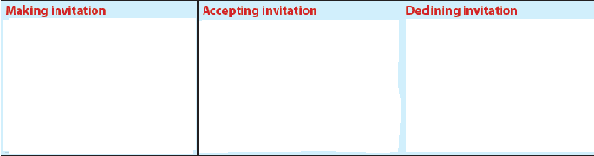

**D)READ THE TEXT AND FILL IN THE CHART (8X2=16)**



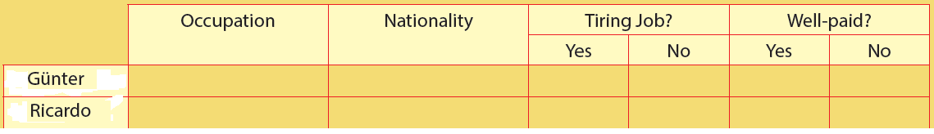

**E)Match them with description. Be careful, there are extra words(5X3=15)**



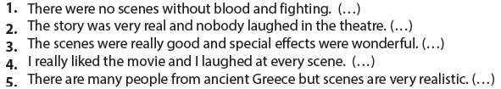

**F)Read the definitions and complete the types of the films.(5X3=15)**

**1.W_ _ f_ _ _:** In this type, there are people fighting and killing each other.

**2. M_ _ _ _ _ _:** This type doesn’t have much action. There is generally a person or a group singing.

**3. A_ _ _ _ _ _d film:** There are cartoon characters or drawing in this type.

**4. A_ _ _ _ _ film:** This type has a lot of scenes full of chases and fights.

**5. C_ _ _ _ _:** You cannot stop laughing when you watch a movie in this type

**2020-2021 ……………….. Anadolu Lisesi 9.Sınıf İngilizce Dersi**

**1.Dönem 1.Ortak Yazılı (Grup B)**

**Name and Surname:**

**Number: Class:**

1. **READ THROUGH THE STATEMENTS AND PUT THEM IN THE CORRECT ORDER (8X3=24)**

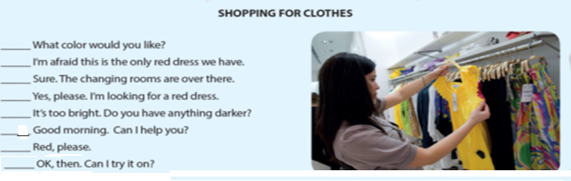

1. **READ THE TEXT AND FILL IN THE CHART (8X2=16)**





**C)Fill in the blanks with the appropriate jobs in the box.Be careful, there are 4 extra jobs(6X3=18)**

|  |
| --- |
| Baker plumber waiter lawyer hairdresser policeman  Nurse engineer architecht shop assistant |

1)when you see a burglar breaking into house,quetly call 155 and wait for the ………….to arrive.

2) I’m afraid I have to change my …………………….immediately.Ihate my hair style.

3)Having a good ………….is a distinct advantage in court.

4)My friend Max works as a ……………………….in a clothes shop.

5)I need to call the………………………………………Water’s leaking from the pipes.

6)Sue is a …………………………… she looks after the patients at a hospital.

D)Match them with description. Be careful, there are extra words (5X3=15)



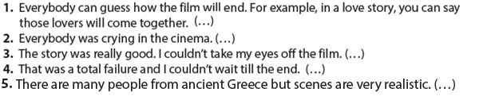

**E)Group the sentences or phrases (6X2=12)**

-That would be very nice -I’m sorry I can’t -Would you like to………

-Could you come to…… -Cool! -I would like to but………



**F) Read the definitions and complete the types of the films.(5X3=15)**

**1. H_ _ _ _ _ film:** There are a lot of frightening scenes in the movie.

**2. T_r_ _ _e_:** You feel the suspense and anxiety in the movie. There is always a surprising situation.

**3. W_ _ _e_ _:** There are cowboys and traditional clothes on people.

**4. D_ _u_ _ _t_ _ _ movie:** This type generally shows something in its real form.

**5. S_ _-_ _ movie:** It has unusual or imaginary scenes and they are mostly very technological.