**SINIFI İNGİLİZCE DERSİ 2. DÖNEM 2. YAZILI SORULARI**

**Name, surname: Number:**

**A- TEST (13x4=52)**

**1. Aşağıdaki eşleştirmelerden hangisinde yanlışlık yapılmıştır?**

|  |  |  |  |
| --- | --- | --- | --- |
| http://thumbs.dreamstime.com/z/fireman-eps-file-simple-gradients-42755288.jpghttp://images.clipartof.com/thumbnails/438069-Royalty-Free-RF-Clip-Art-Illustration-Of-A-Cartoon-Judge-Leaning-Over-His-Desk.jpghttps://s-media-cache-ak0.pinimg.com/236x/4e/10/e8/4e10e8ebec954388a2e1b690acb4d5a9.jpg**A)**  Fireman | **B)**  Butcher | http://fscomps.fotosearch.com/compc/CSP/CSP244/k2446702.jpghttp://previews.123rf.com/images/clairev/clairev1008/clairev100800038/7630248-Cartoon-taxi-driver-Stock-Photo.jpg**C)**  Tailor | **D)**  Driver |

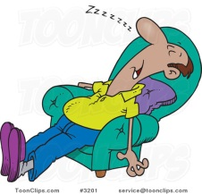**2. Görsele göre sorunun cevabı hangi seçenektedir?**

What does your father do after lunch?

|  |
| --- |
| **A)** He has a snack. |
| **B)** He hangs around with his friends. |
| **C)** He takes a nap. |
| **D)** He is waiting for the bus. |

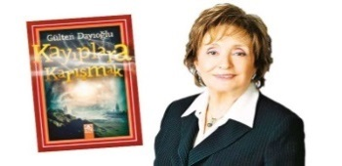**3. Altı çizili olan *yılın* doğru şekilde gösterildiği seçeneği işaretleyiniz.**

*Gülten Dayıoğlu is a famous author. She wrote*

*her first novel Fadiş in* ***nineteen seventy –one.***

|  |  |  |  |
| --- | --- | --- | --- |
| **A)** 1917 | **B)** 1977 | http://thumb1.shutterstock.com/display_pic_with_logo/1069388/277113710/stock-vector-animal-doctor-277113710.jpg**C)** 1901 | **D)** 1971 |

**4. Boşluğa uygun seçeneği işaretleyiniz.**

*He loves animals very much. He examines sick animals. He is a ___.*

|  |  |  |  |
| --- | --- | --- | --- |
| **A)** worker | **B)** milkman | **C)** journalist | **D)** vet |

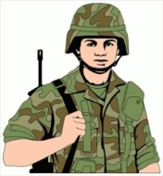**5. Cümleyi doğru olarak tamamlayan seçeneği işaretleyiniz.**

*“My brother is a soldier. He wears a uniform.*

*He works in the army and.....................”*

|  |
| --- |
| **A)** paints the walls |
| **B)** works in a bank |
| **C)** protects the country |
| **D)** drives a taxi |

**6. Diyoloğu tamamlayan seçeneği işaretleyiniz.**

*David: My brother is a very talented person.*

*Johnny: Really? ........................ ?  
 David: He can play the piano very well and sing a song at the same time.*

|  |  |
| --- | --- |
| **A)**  What do they do | **B)**  What can he do |
|  |  |
| **C)**  What is his job | **D)**  What does she like |

**7. Boşlukları doğru olarak tamamlayan seçenek hangisidir?**

*Our football match is ..... 4 pm .... Friday.*

|  |  |  |  |
| --- | --- | --- | --- |
| **A)** at / on | **B)** on /in | **C)** on / at | **D)** in / on |

**8. Konuşmayı anlamlı bir şekilde tamamlayan seçeneği işaretleyiniz.**

I don’t know but I like designing and drawing modernbuildings.

What is your dream job?

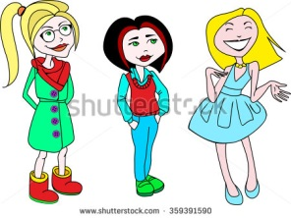

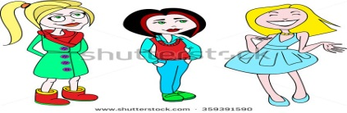

|  |  |
| --- | --- |
| **A)** I want to be a cook . | **B)** You should study medicine. |
| **C)** You should be a journalist. | **D)** You should be an architect. |

**9. Paragrafın *anlam akışını bozan* cümle hangisidir*?***

***I)*** *My name is Arthur. Last weekend I went camping with my friends.* ***II)*** *We took our trekking shoes and mountain bikes. Because we love cycling and trekking. We walked in the forest and picked berries.* ***III)*** *Before the flight, we checked everything in the cockpit and organized a meeting with the crew.* ***IV)*** *At night we made a campfire and sat around it. Then, we slept in our tents.*

|  |  |  |  |
| --- | --- | --- | --- |
| **A)** I | **B)** II | **C)** III | **D)** IV |

**10. Cümledeki boşluğa uygun olan seçeneği işaretleyiniz.**

*Bruce ......... space. He wants to become an astronaut.*

|  |  |  |  |
| --- | --- | --- | --- |
| **A)** hates | **B)** likes | **C)** dislike | **D)** doesn’t like |

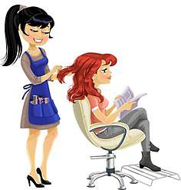**11. Verilen cevaba göre hangi soru sorulmalıdır?**

Yes, I can. I’m a hair dresser.

….……?

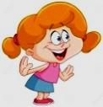

|  |  |
| --- | --- |
| **A)** Can you paint the fences | **B)** Can you cut hair |
| **C)** Can you make delicious cakes | **D)** Do you deliver letters |

**12. Diyalogdaki boşlukları tamamlayan seçenek hangisidir?**

*- ………did you do in Antalya?*

*- I …….. some museums and historical monuments.*

|  |  |
| --- | --- |
| **A)** What / visited | **B)** How / buy |
| **C)** When / slept | **D)** Who / took |

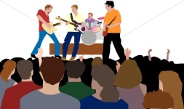**13. Konuşmadaki boşlukları tamamlayan seçenek hangisidir?**

***Alice:*** *Were you at the concert last night?*

***Kate:*** *___. They___ our favourite songs.*

|  |  |
| --- | --- |
| **A)** Yes,I do / saw | **B)** No,I wasn’t / sing |
| **C)** No,he wasn’t / sang | **D)** Yes,I was / sang |

**B) Write the correct description to the gaps (7x2=14)**

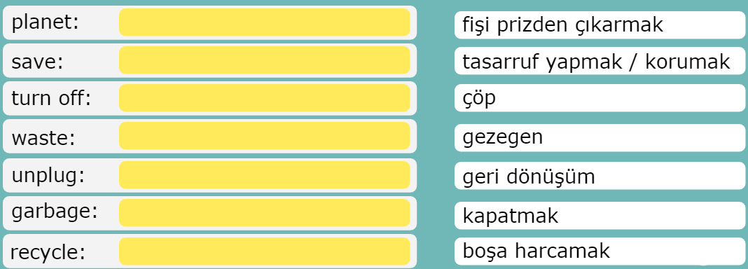

**C) Match the definitions with the pictures (4x3=12)**

|  |
| --- |
| **unplug the TV pick up the rubbish put the garbage into recycle bin cut down the trees** |

|  |  |  |  |
| --- | --- | --- | --- |
|  |  |  |  |
|  |  |  |  |

**D) Which thief is the detective looking for? Put a tick ( √ ) (10 points)**



The thief is wearing a mask and a hat. He isn’t short and he isn’t fat. He has got a big nose. He is wearing black trousers and black shoes. He is carrying a bag full of money. Who is the thief?

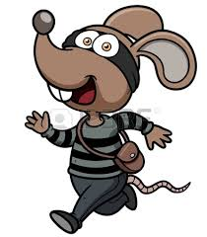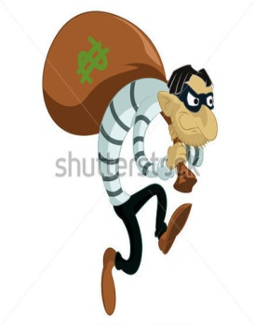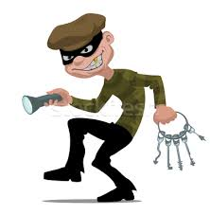

**E) Match the correct words with the pictures (6×2=12)**

**magnifier / painting / footpints / jewellery / burglar / break into beakbroke into**

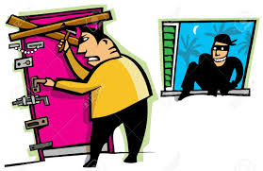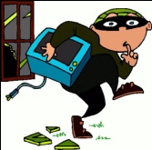

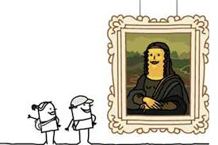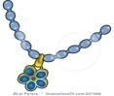

____________ ____________ ______________ _____________ _______________

**☺ GOOD LUCK! ☺**

**English Language Teache**