4th CLASS SECOND TERM FIRST WRITTEN ENGLISH EXAM

Name/Surname: Class/Number:
A.BOŞLUKLARI UYGUN KELIMELERLE DOLDURUN.(4X6=24P)
POLICEMAN – FARM – TEACHER – POLICE STATION – FARMER – SCHOOL – CHEF – FIRE STATION – DOCTOR – RESTAURANT – HOSPITAL - FIREMAN

1. I am a ………………………………… 2. I am a …………………………………….. 3. I am a ……………………………………..
I work at ………………………….. I work on a ………………………………. I work at …………………………. .

4.I am a ………………………………… 5. I am a ………………………………… 6. I am a …………………………………
I work at …………………………… I work at a ………………………….. I work at ………………………………
B.SORULARI CEVAPLARIYLA EŞLEŞTİRİNİZ.(4X5=20P)

1-What do you do in the mornings? -------- a) I go shopping on Sundays.
2- What time is it? -------- b) I go to bed at night.
3- Where is the dog? ------- c) I brush my teeth in the mornings.
4- When do you go shopping? -------- d) It is ten o’clock.
5- What do you do at night? -------- e) It is under the tree.
C.DOĞRU ŞIKKI SEÇINIZ.(1x10=10P)
1. PLANT a.Bitki b. Su c. Toprak d. Çakıl taşı
2. SCIENCE a. Bilim insanı b. Bilim c. Kutu d. Fasülye
3. FOLD a.Dökmek b. Yerleştirmek c. Katlamak d. Kesmek
4. EXPERIMENT a. Bilim b. Deney c. Toprak d.Makas
5. BOTTLE a. Şişe b. Kavanoz c. Tüp d.Bardak
6. SOIL a.Saksı b)Gıda boyası c.Makas d.Toprak
7. PAPER a.Su b)Kağıt c.Boya d.Gözlük
8. FILL a.Doldurmak b)Dökmek c)Koymak d.Dondurmak
9. WATER a. Kutu b)Kavanoz c.Su d.Kap
10. BRUSH a.Dökmek b)Fırçalamak c.Örtmek d.Sallamak

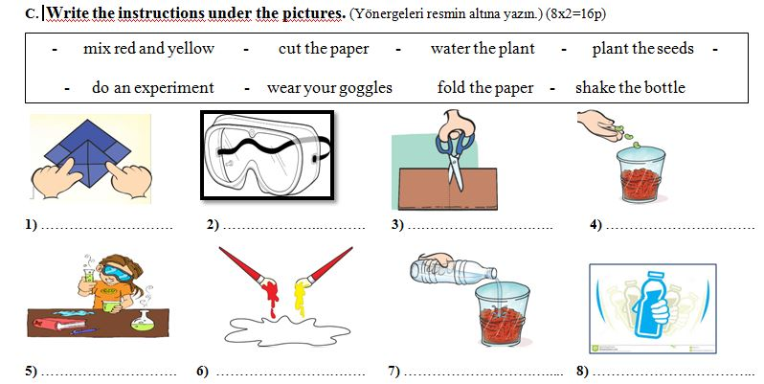
E) BOŞLUKLARI UYGUN KELIMELERLE DOLDURUN.(3X5=15P)
IN - ON - NEAR - BEHIND - IN FRONT OF

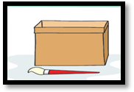  1. Where is the brush?  It is ……………................... the box. | 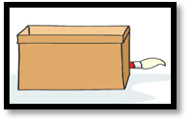  4.Where is the brush?  It is ……………..........the box.
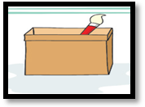  2.Where is the brush?  It is ……………............. the box. | 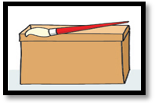  5. Where is the brush?  It is ……………...........the box.
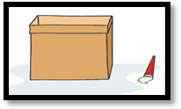
3.Where is the brush?
It is ……………............. the box.
F)GÜNLERİ DOĞRU SIRAYA KOYUNUZ.(2x7=14P)
SATURDAY - TUESDAY - MONDAY - WEDNESDAY - SUNDAY - THURSDAY - FRIDAY

1………………………………… 5…………………………….
2……………………………….. 6…………………………….
3………….…………………… 7…………………………….
4………………………………..
GOOD LUCK☺
Time: 40 min.
Ayşen KARABEKE

