 | 2019-2020 EDUCATION YEAR  ........................ PRIMARY SCHOOL  4th GRADE ENGLISH LESSON 1st TERM 2nd EXAM | Point:
 | Name - Surname : Number : | Point:
 | Date : .... / ... / ....... | Point:

1. What is this ?
It is a __________ .


A) book
B) pencil
C) eraser
D) notebook

2. What is this ?
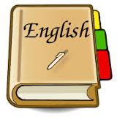
It is a __________ .

A) book
B) eraser
C) sharpener
D) school bag

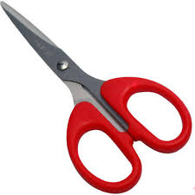
3. What is this ?
It is a __________ .

A) ruler
B) window
C) whiteboard
D) scissors

4. Görselde verilen işareti yerine ne
getirilmelidir ?
four
two
one
three

A) books
B) numbers
C) doors
D) animals

5. ..............your book.
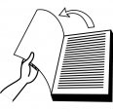
A) open
B) close
C) clean
D) take

6. Öğretmen Gizem’e yerinden kalkmasını
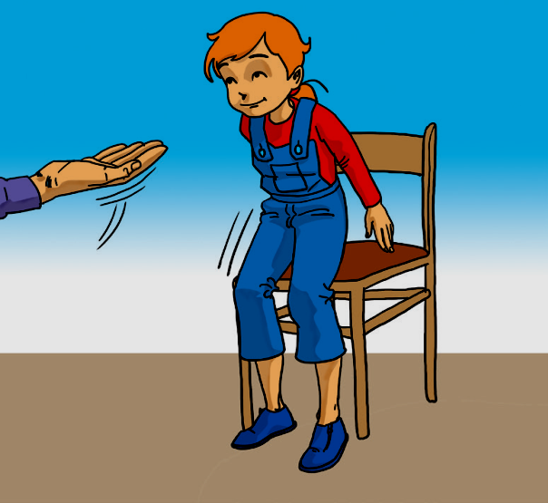
nasıl söyker ?

A) Open your book !
B) Stand up !
C) Clean the whiteboard !
D) Sit down !
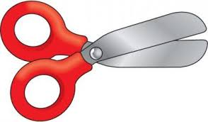

7. Aşağıdaki ifadeyi tamamlamak için boşluğa
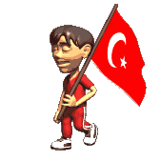
hangi soru kelimesi getirilmelidir ?
____ are you from ?
I am from
Turkey .

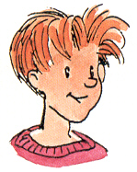

A) How B) What C) Who D) Where

8 Which country is it ?
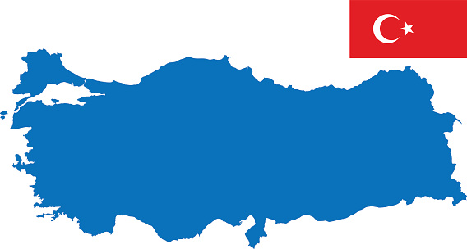
A) Italy
B) Turkey
C) Brazil
D) Greece

9. Where are you from ?
Sorusu Türkçe'de ne demektir ?
A) Nerede yaşıyorsunuz ?
B) Kaç yaşındasınız ?
C) Nerelisiniz ?
D) Nasılsınız ?

10. Which one is different ?
( Hangisi farklıdır ? )

A) Monday B) Tuesday
C) Friday D) Summer

11. What do you do in the evening ?

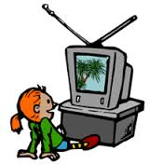
A) I set the table.
B) I have dinner
C) I watch TV.
D) I put on my pyjamas.

12. What time is it ?

A) It's ten o’clock.
B) It's nine o’clock.
C) It's six o’clock.
D) It's eight o’clock.

13. What time is it ?

A) It's twelve o’clock.
B) It's eleven o’clock.
C) It's ten o’clock.
D) It's one o’clock.

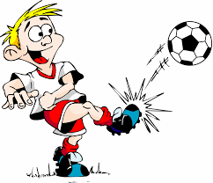
14. He can__________ .

A) play the quitar
B) play handball
C) drive a car
D) play football

15. I like playing__________________ .

Görsele göre ; cümleyi seçeneklerden
hangisi tamamlar ?

A) football
B) volleyball
C) basketball
D) the quitar


16. Do you like dancing ?

A) No,I can’t.
B) Yes, I can.
C) Yes, I do.
D) No, I don’t.

17. Do you like riding a bike ?


A) No, I don’t.
B) Yes, I do.
C) No,I can’t.
D) Yes, I can.

18. Where do you live ?

A) Thanks I’m fine and you.
B) My name is Hasan.
C) I’m from Turkey.
D) I live in Sinop.

19. Ali : I like playing football.

Sema :___________________
Ali : I like playing football.

Boşluğa hangisi getirilirse ifade anlamlı olur?

A) Yes I do. B) No,I can't
C) Yes I am. D) Pardon

20. Resimdeki aktivite hangi şıkta doğru


olarak verilmiştir ?

A) I like playing the quitar.
B) I like watcing TV.
C) I like riding a bike
D) I do reading a book.

Every question is 5 point !
www.derskitabicevaplarim.com

