________________________________________________ HIGH SCHOOL EDUCATION YEAR
12. GRADE SECOND SEMESTRE FIRST EXAMINATION
Name and Surname: Class: Number: Date:
LISTENING PART
A. LISTEN AND DO THE EXERCISES. EPISODE 4. 21 POINTS.
I. Listen and choose the correct answer.

1. Where are the men's clothes?
- In the basement.
- On the ground floor.
- On the first floor.
2. Where are the women's clothes?
- In the basement.
- On the ground floor.
- On the first floor.

II. Listen and order the phrases.
___Take the lift.
___And when you come out,
___then left a bit
___go straight on,
___and you'll see me
B. LISTEN AND DO THE EXERCISE. EPISODE 5. 18 POINTS.
I. Listen and mark as TRUE or FALSE.
1.Sammy's surname is 'North'. _______
2.

Sammy agrees to meet the man at nine thirty tomorrow. _______
3.

Julia agrees to meet Jack at seven o'clock tomorrow. _______
4.

Jack is Julia's brother. _______
5.

Andrea is Sammy's friend. _______
6.

Andrea is a man. _______
C. LISTEN AND DO THE EXERCISES. EPISODE 6. 30 POINTS.
I. Listen and choose the correct answer.

1.Who has chicken soup?
- Julia
- Sammy
- Julia and Sammy
2. Who has steak and chips?
- Julia
- Sammy
- Julia and Sammy

3. Who has lasagne?
- Julia
- Sammy
- Julia and Sammy
4. Who pays for the meal?
- Julia
- Sammy
- Julia and Sammy

II. Listen and order the lines.
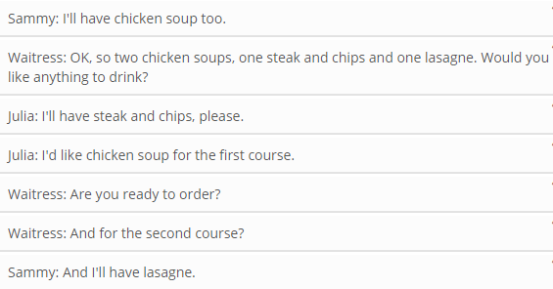

1.

READING AND VOCABULARY PART.

D. READ THE STORY AND ANSWER THE QUESTIONS.
Two Wolves One evening an old Cherokee and his grandson were sitting by the Indian campfire. All the members of the tribe were celebrating the Thanksgiving Day and the women were serving turkey and corn to everybody. While they were enjoying their meal, they suddenly heard the howl of the wolves. The grandson got scared and asked the old Cherokee: “Grandpa, why are the wolves howling like that, are they fighting?” The old man smiled and sipped his drink while the little Indian was looking at his wrinkled nut-brown face curiously. When the old Cherokee began to talk, everybody sitting round the fire wasn’t talking anymore but listening to him silently. He said: "My son, the real battle is between two "wolves" inside us all. One is black and the other is white. The black one is Evil. It is sorrow, anger, jealousy, regret, greed, guilt and ego. The white one is Good. It is joy, peace, love, hope, generosity, truth and empathy." The grandson thought about it for a minute and then asked his grandfather, "Which wolf wins grandpa?" The old Cherokee wisely smiled and simply replied, "The one you feed, my son."
Origin Unknown
1. What were the members of the tribe celebrating? ......................................................................
2. Were the women of the tribe serving chicken and rice for the celebration? ...............................
3. What did they suddenly hear while they were enjoying their meal? ...........................................
4. Was everybody listening to the story of two wolves? ................................................................
5. What does the black wolf symbolize? .......................................................................................
6. What does the white wolf symbolize? .......................................................................................

E. WRITE A PARAGRAPH ABOUT YOUR PHOBIAS AND HOBBIES CONSIDERING THE USEFUL EXPRESSIONS GIVEN.
Useful Expressions: (to be) scared of... afraid of... fond of... keen on... interested in... good at... bad at... want... decide... refuse...continue... begin... / enjoy ...like... love... hate... dislike... / make... let.. help...

