
ACADEMIC YEAR 2nd TERM 1st ENGLISH WRITTEN EXAM for 11-A/B/C

Full Name: Class – Number:
A)Read the advice coloumn and answer the questions (26 points)

Dear Advice Guru,
Something really bad happened. We moved to another citybecause my mother changed her job! I still feel terrible about this.
In my hometown, I had a lot of good friends. We used to study and spend time together all the time. My best friends were there, too. Whenever I was in trouble, I had best friends to talk about it and they were always able to sort out that problem. My mother never told me about her plans, so I was shocked!
We moved here three months ago and I haven’t had a new friend, yet. My life here seems unbearable . I can’t stand living in this city. This city is smaller and it lacks social activities. There are only three big shopping malls! Although it is by the sea and there are a lot of cafés to go, I have no friends, so they are useless. My mother keeps telling me that I will get used to living here, but I don’t think so.
People here are really communicative and talk too much. They try to interact with me all the time, asking many questions. I don’t like to be inquired! I don’t answer their questions most of the time and my parents get mad at me! What should I do? Please help me.
Best,
Desperately Lonely.

Questions
1. Why did they have to move to another city?(3 p)

2. How was her life in her hometown?(5p)

3. What makes life unbearable in the new city?(5p)

4. What kind of people live in the new city?(4p)

5. Write 3 things(advices) she should has done.What should she has done?(9p)
-
-
-

B)Write 10 sentences about your regrets.(10x2,5=25 points)

example: I wish I had studied my lesson before exam.
1)
2)
3)
4)
5)
6)
7)
8)
9)
10)

C) Read the situations under each picture and write sentences on what must/might/can/could/can’t .. have happened?(9x3=27points)
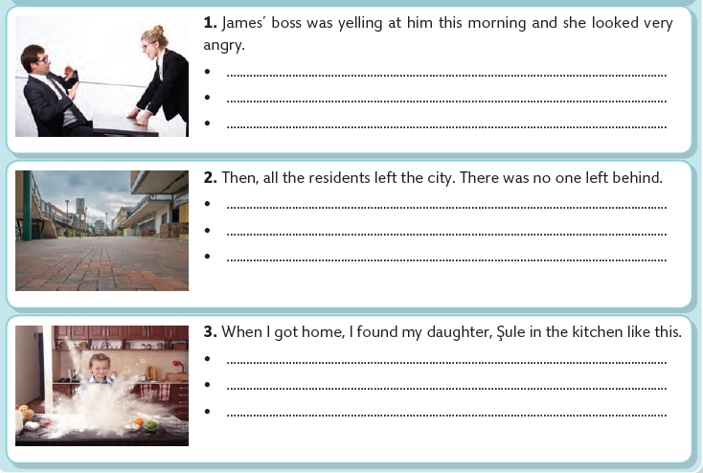

F.Write Turkish meanings of the words (22x1=22 points)

-cheat:
-ashamed:
-consequence:
-resident:
-take up:
-satisfaction:
-leisure time:
-bearable:
-call center:
-juggling:
-useless:
-flock:
-shepherd:
-liquid
-dramatically:
-profession:
-bully:
-fetch:
-slayer:
-profuse:
-remorse:
-axe:

https://www.HangiSoru.com

GOOD LUCK
English Language Teacher

